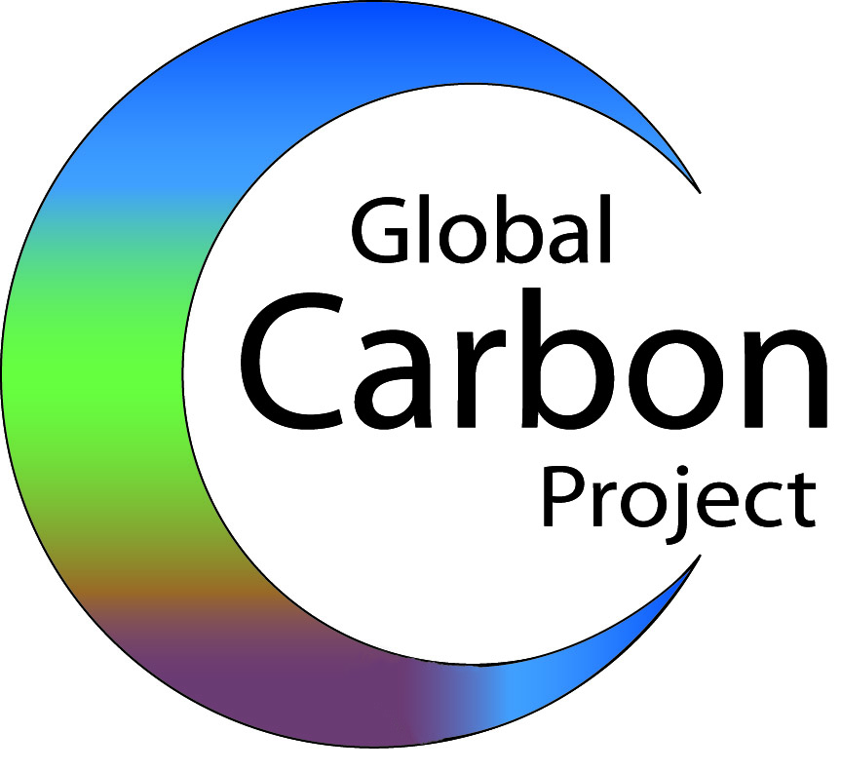
For further information, please contact:
Dr Mike Raupach,
The Global Carbon Project
Michael.Raupach@csiro.au
+61 2 6246 5573; +61408 290 825
Posted By: The Global Carbon Project

21 May 2007 Global and regional drivers of accelerating CO2 emissions
Global economy more carbon intensive, not less

A new analysis shows that carbon intensity in the world economy is increasing. While emissions of carbon dioxide (CO₂) are accelerating worldwide, we are gaining fewer economic benefits from each tonne of fossil fuel burned.

A study published this week in the Proceedings of the National Academy of Science shows that CO₂ emissions increased by 1.1 % per year through the 1990s but the rate of increase jumped to 3 % per year in the 2000s.

The study analysed emissions from both developed and developing regions. Lead author of the paper, Dr Mike Raupach from the Global Carbon Project and CSIRO, says that "The world's developing regions are the places where emissions are growing fastest in relative terms. However, this only means that developing regions are catching up: they are still a long way behind the developed regions in terms of total emissions".

"The developed regions, representing just 20% of the world's population, account for nearly 60% of current emissions and 80% of cumulative CO₂ emissions since the beginning of the Industrial Revolution. These cumulative emissions are the leading cause of current climate change”, says Dr Raupach.

“A major driver accelerating the growth rate in global emissions is that, globally, we’re burning more carbon per dollar of wealth created. In the last few years, the global use of fossil fuels has actually become less efficient. This adds to pressures from increasing population and wealth”.

Dr. Pep Canadell, co-author of the paper and executive director of the Global Carbon Project says "In the unfolding reality since 2000, the average global carbon intensity of energy has actually deteriorated (increased) and no region is showing signs of decarbonising its energy supply. The emissions growth rate since 2000 was greater than for the most fossil-fuel intensive of the Intergovernmental Panel on Climate Change emissions scenarios developed in the late 1990s".

The results strengthen findings that observed CO₂ concentrations, global temperatures and sea level rise are all near or above the high end of the CO₂ emission projections of the United Nations-IPCC.

As the Global Carbon Project chair, Dr Raupach led an international team of economists, carbon-cycle experts and emissions experts, to develop a regionalized analysis of trends in emissions and their demographic, economic and technological drivers. Using the Kaya identity (a technique for identifying the drivers of CO₂ emissions), they analyzed the relationship between emissions and global population, world GDP (or gross world product) and world energy consumption.

Michael R. Raupach*†, Gregg Marland‡, Philippe Ciais§, Corinne Le Que´ re´ ¶, Josep G. Canadell*, Gernot Klepper_, and Christopher B. Field**
*Global Carbon Project, Commonwealth Scientific and Industrial Research Organisation Marine and Atmospheric Research, Canberra, ACT 2601, Australia; ‡Carbon Dioxide Information Analysis Center, Oak Ridge National Laboratory, Oak Ridge, TN 37831; §Commissariat a l’Energie Atomique, Laboratorie des Sciences du Climat et de l’Environnement, Gif sur Yvette, 91191, France; ¶University of East Anglia/British Antarctic Survey, School of Environment Sciences, Norwich, 1 NR4 7TJ, United Kingdom ; _Kiel Institute for the World Economy, D- 24105 Kiel, Germany; and **Carnegie Institution of Washington, Department of Global Ecology, Stanford, CA 94305

Notes for editor
EMBARGOED FOR RELEASE UNTIL Thursday, May 21, 17:00 EDT (21:00 HRS GMT) - Copies of the paper will be available after this time, freely available online through the PNAS open access option. www.pnas.org_cgi_doi_10.1073_pnas.0700609104
and http://www.globalcarbonproject.org
Global Carbon Project contact: Mike Raupach
Tel: +61 2 6246 5573 or email Mike.Raupach@csiro.au

IMMEDIATELY AVAILABLE BACKGROUND INFORMATION and full text submitted article: http://www.globalcarbonproject.org/activities\PNAS_May07\PNAS_Article_May07.html
IF REPORTING ON THIS STORY PLEASE MENTION THE GLOBAL CARBON PROJECT AS THE SOURCE AND, IF PUBLISHING ONLINE, PLEASE CARRY A HYPERLINK TO : http://www.globalcarbonproject.org
The Global Carbon Project was formed to assist the international science community to establish a common, mutually agreed knowledge base supporting policy debate and action to slow the rate of increase of greenhouse gases in the atmosphere.
Reference URL
http://www.globalcarbonproject.org
Peer reviewed publication and references after 21 May 2007
This article is a PNAS Direct Submission. Freely available online through the PNAS open access option. www.pnas.org_cgi_doi_10.1073_pnas.0700609104
Supporting information online: www.pnas.org/cgi/content/full/0700609104/DCI

