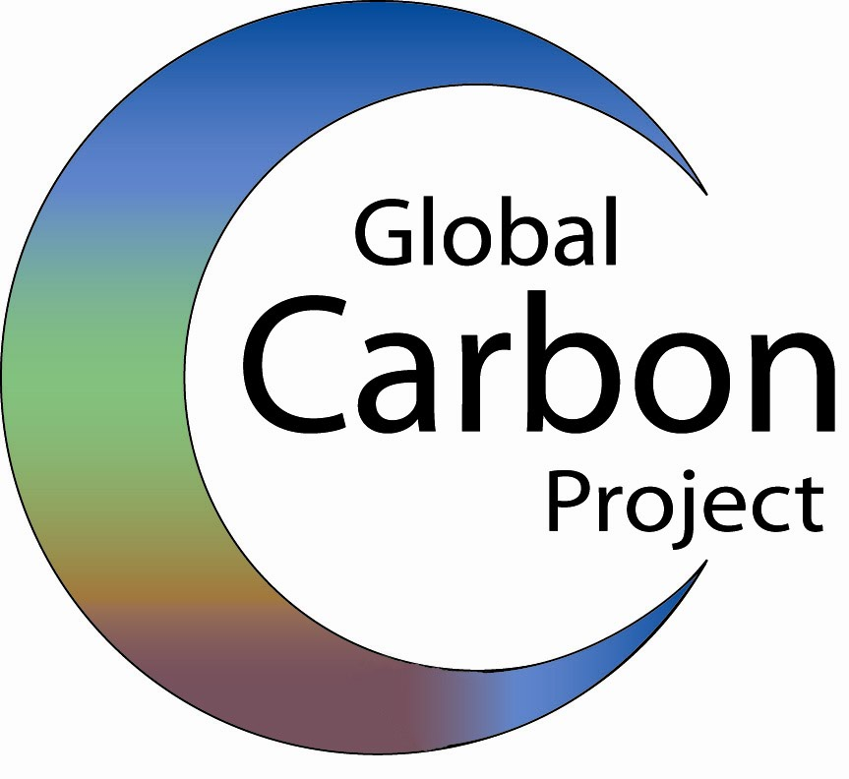
For further information, please contact:  Dr Pep Canadell,  The Global Carbon Project  Pep.Canadell@csiro.au  +61 407 068 930 | Dr Corinne Le Quere  University of East Anglia  Email: c.lequere@uea.ac.uk Tel: 44-1603-592840

22 October 2007
Contributions to accelerating atmospheric CO₂ growth from economic activity, carbon intensity, and efficiency of natural sinks
under embargo until 22 October 2007 17:00 EDT (21:00 HRS GMT)
Carbon sink slowdown contributing to rapid growth in atmospheric CO₂

There has been a decline in the efficiency of natural land and ocean sinks which soak up carbon dioxide (CO₂) emitted to the atmosphere by human activities, according to findings published this week in the Proceedings of the National Academy of Sciences of the US (PNAS).

The swift increase in atmospheric CO₂ is due to faster economic growth coupled with a halt in carbon intensity reductions, in addition to natural sinks removing a smaller proportion of emissions from the air. Carbon intensity is the amount of carbon emitted to produce one dollar of global wealth.

The study’s lead author, Dr Pep Canadell, executive director of the Global Carbon Project, explained “Fifty years ago, for every tonne of CO₂ emitted, 600kg were removed by natural sinks. In 2006 only 550kg were removed per tonne and that amount is falling.”

“In addition to the growth of global population and wealth, we now know that significant contributions to the growth of atmospheric CO₂ arise from the slow down of natural sinks and the halt to improvements in carbon intensity.”

The rise in growth in atmospheric CO₂ is generating climate forcings that are bigger and sooner than expected. By altering the global energy balance, these mechanisms "force" the climate to change.

“There are regional differences in the efficiency of natural sinks. Half of decline in the efficiency of the ocean sink is due to the intensification and poleward movement of the westerly winds in the Southern ocean”, said contributing author Corinne Le Quere of the University of East Anglia.

“The proportion of carbon dioxide remaining in the atmosphere after vegetation and the oceans absorb what they can has escalated over the past 50 years, showing a decrease in the planet’s ability to absorb anthropogenic emissions.” said Dr Canadell.

Dr Raupach, co-chair of the Global Carbon Project, said ”We have found that the earth is losing its restorative capacity to absorb CO₂ emissions in the face of the massive increases in emissions over the last half century. The longer we delay reducing emissions, the more restorative capacity will be lost."

The majority of these authors are members of the Intergovernmental Panel on Climate Change which was recently awarded the Nobel Peace Prize 2007.

Josep G. Canadella,b, Corinne Le Quere c,d, Michael R. Raupacha, Christopher B. Fielde, Erik T. Buitehuisc, Philippe Ciaisf, Thomas J. Conwayg, Nathan P. Gillettc, R. A. Houghtonh, and Gregg Marlandi,j
aGlobal Carbon Project, Commonwealth Scientific and Industrial Research Organisation Marine and Atmospheric Research, GPO Box 3023, Canberra ACT 2601, Australia; cSchool of Environment Sciences, University of East Anglia, Norwich NR4 7TJ, United Kingdom; dBritish Antarctic Survey, Madingley Road, Cambridge CB3 0ET, United Kingdom; eDepartment of Global Ecology, Carnegie Institution of Washington, Stanford, CA 94305; fLaboratorie des Sciences du Climat et de l’Environnement, Commissariat a L’Energie Atomique,, 91191 Gif sur Yvette, France; gNational Oceanic and Atmospheric Administration Earth System Research Laboratory, Boulder, CO 80305; hWoods Hole Research Center, Falmouth, MA 02540; iCarbon Dioxide Information Analysis Center, Oak Ridge National Laboratory, Oak Ridge, TN 37831; and jInternational Institute for Applied Systems Analysis, A-2361 Laxenburg, Austria

Notes for editor
EMBARGOED FOR RELEASE UNTIL Monday, October 22, 17:00 EDT (21:00 HRS GMT) - Copies of the paper will be available after this time, freely available online through the PNAS open access option.

PNAS Early Edition article http://www.pnas.org/papbyrecent.shtml

Global Carbon Project contact: Pep Canadell
Tel: +61 407 068 930 or email Pep.Canadell@csiro.au

IMMEDIATELY AVAILABLE BACKGROUND INFORMATION and full text submitted article: http://www.globalcarbonproject.org
IF REPORTING ON THIS STORY PLEASE MENTION THE GLOBAL CARBON PROJECT AS THE SOURCE AND, IF PUBLISHING ONLINE, PLEASE CARRY A HYPERLINK TO : http://www.globalcarbonproject.org
The Global Carbon Project was formed to assist the international science community to establish a common, mutually agreed knowledge base supporting policy debate and action to slow the rate of increase of greenhouse gases in the atmosphere.
Reference URL
http://www.globalcarbonproject.org
Peer reviewed publication and references after 22 October 2007
PNAS Early Edition article http://www.pnas.org/papbyrecent.shtml
This article is a PNAS Direct Submission.
Freely available after publication online through the PNAS open access option.

