Vulnerabilities of the Global Carbon Cycle in the 21st Century

GCP Activity – Overview and Progress

23 August 2006

Prepared by Pep Canadell, Chris Field, Corinne Lequere, Nebojsa, Nakicenovic, Mike Raupach

Problem Statement

Earth system processes that cause carbon loss to the atmosphere could greatly accelerate climate change during this century. Potentially vulnerable carbon pools that currently contain hundreds of billion tons of carbon could be destabilized through global warming and land use change. Some of the most vulnerable pools on land and oceans are: soil carbon in permafrost, soil carbon in high- and low-latitude wetlands, biomass-carbon in forests (trees and soils), methane hydrates in the coastal shelfs, and ocean carbon concentrated by the biological pump (Fig. 1). Preliminary analyses indicate a risk over the coming century that may be larger than 200 ppm of atmospheric CO₂, rivalling the expected release from fossil fuel combustion (Gruber et al. 2004). Such a massive release of greenhouse gases to the atmosphere would result in higher concentrations of atmospheric CO₂, accelerating climate warming, and potentially stimulating even greater losses of carbon from vulnerable pools. The risk of large losses from these pools is not well known, and is not included in most climate simulations.

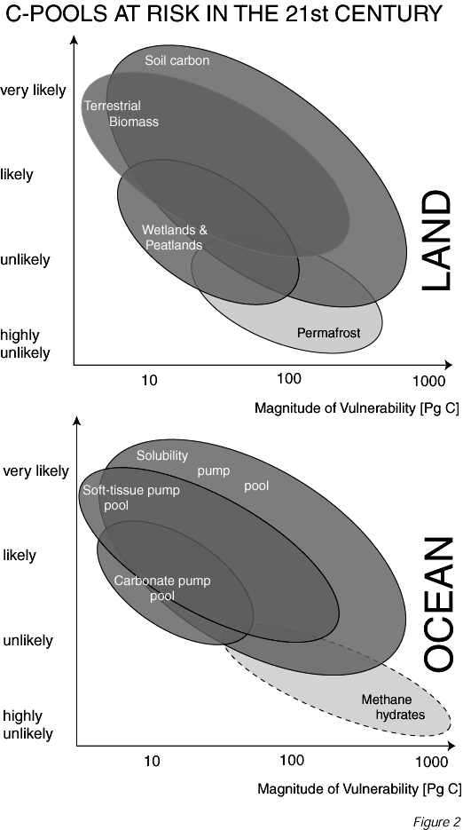

Figure 1. Magnitude and Vulnerability of C pools on land and oceans (SCOPE-GCP synthesis: Gruber et al. 2004).

At present, there is no comprehensive analysis of the size of vulnerable pools on land and in the oceans, and their potential dynamics during this century; nor is there an assessment of their possible collective feedbacks to climate change.

Furthermore, some of the pools could be managed through human responses to local and regional impacts which in turn have a negative feedback on global emissions. Little research has been undertaken in linking these various dynamics operating at different scales and for different purposes to preserve large carbon stocks (Figure 2).

The biggest obstacles to progress in understanding the overall feedbacks and the potential for managing these pools are the lack of:
- spatially explicit data on the sizes of the pools;
- understanding of key processes involved in the destabilization of pools including proximal and distant drivers in the climate, biospheric, land use, and energy systems.
- credible algorithms and modelling tools for simulating the vulnerability of these pools to the various forcings with the goal to integrated them into earth system models or other analitical or prognostic modelling frameworks;
- trends of future forcing, both in climate change, land use, and energy demands/economics.
- good understanding of the human impacts and responses that could make these pools further vulnerable (positive feedback) or resilient (negative feedback).

Climate System
Vulnerable
C Pools
Human System
Land Use System
Energy System
Local, Regional,
& Global
Communities
X

Figure 2. Vulnerability and resilience of large carbon pools

Implementation – Ongoing Activity

All activity relates to the sensitivity of carbon pools and fluxes to human actions (through the systems of land use and energy) and climate change, and how the related impacts on humans and their responses can further destabilize (positive feedback) the carbon pools or build resilience (negative feedback).

The selection of pools are based on the following criteria:
- magnitude of pool should be substantial
- level of uncertainty about large carbon losses should be substantial
- missing from current models or scenarios
- risks of long-term irreversible effects and feedbacks

- Vulnerability of carbon in permafrost: Pool size and potential effects on the climate system

Background
Frozen soils hold over 400 Pg C which have been accumulated over thousands of years (Sabine et al. 2004). Approximately 54% of frozen soils occur in Eurasia, largely in Russia, and 46% in North America, largely in Canada (Tarnocai et al. 2003). Additional 500 Pg C exist in frozen loess that have been accumulated in glacial times in the north planes of Siberia (Zimov et al. 2006). With the rapid warming of the northern latitudes well above the global averages (IPCC 2001), C in frozen soils can be exposed to warmer aerobic conditions which would result in increased decomposition of soil organic matter and thus C emissions. In fact, widespread observations exist of permafrost thawing leading to the development of thermokarst and lake expansion, followed by lake drainage as the permanent permafrost further degrades (Camill 2005; Smith et al. 2005).

Recent estimates using a fully coupled GCM show that of the 10 million km2 of present-day permafrost as little as 1 million km2 near surface permafrost will remain by the end of this century (Lawrence et al. 2005). Melting permafrost will increase CO₂ and CH₄ emissions, and it is estimated for the Canadian permafrost alone that up to 48 Pg C could be sensitive to oxidation under a 4°C warming scenario (Tarnocai 1999).

In addition to C exchange between land and atmosphere, lateral transport of DOC from thawing permafrost is another process by which C is lost from peatlands. Cold permafrost watersheds in Western Siberia release little DOC to the rivers while permafrost-free watersheds show considerably higher amounts that are proportional to the extent of the peatland area (Frey and Smith 2005). For Western Siberia, climate models predict a doubling of the area above a mean average temperature of -2˚C (which coincides with permafrost distribution) and an associated 700% increase in DOC concentrations in streams. Part of the DOC reaching the Arctic Ocean will oxidize and return to the atmosphere.

A preliminary global estimate suggests that up to 5 Pg C could be released from permafrost over the next 20 years and up to 100 Pg C in the next 100 years if they assumed that 25% of the C locked in frozen soils could be oxidized (Gruber et al. 2004; Raupach and Canadell 2006). This amount could increase to as much as 200 Pg C if we include the loess frozen sediments which have been recently reported. Whether this C is released initially as CO₂ or as CH₄ depends on the local hydrological conditions). Although studies suggest an increased gross C uptake by the newly established vegetation (Payette et al. 2004), long term warming and fertilization studies show increased losses of C from deep soil layers (Mack et al. 2004). These losses were sufficient to counteract increased plant biomass C, thereby contributing a net C flux to the atmosphere.

Goals
  - To assess the extent and size of the carbon pools in frozen ground
  - To understand and quantify the processes that relate to the temperate sensitivity to thawing frozen ground.
  - To synthesize our best projections on future trajectories of permafrost thawing at double CO₂.
  - Emission impacts on climate change by 2100

Leadership, Partnerships, and Participants
Chris Field and Pep Canadell are leading the activity and have put together a working group (see below) to develop a number of new products and modelling runs within 3 years. In order to bring the key players into the activity and the community recognition of this activity, the GCP has develop a partnership with the International Permafrost Association (IPA) and the Climate and the Cryosphere (CliC) core project of WCRP.

Participant Name | Institution | Country
Christopher B. Field | Carnegie Institution, Stanford | USA
Josep G. Canadell | CSIRO-Marine and Atmospheric Research | Australia
Frederick E. Nelson | University of Delaware | USA
James Bockheim | University of Wisconsin | USA
Charles Tarnocai | Agriculture and Agri-Food, Ontario | Canada
Galina Mazhitova | Russian Academy of Sciences | Russia
Peter Kuhry | University of Stockholm | Sweden
Sergey V Goryachkin | Russian Academy of Sciences | Russia
Sergei Zimov | Pacific Institute of Geography | Russia
Eugenie Euskirchen | University of Alaska | USA
Ted Schuur | University of Florida | USA
Peter Lafleur | Trent University, Peterborough, Ontario | Canada
Stefan Hagemann | Max-Planck Institute for Meteorology | Germany
Sergey Venevsky | Hadley Centre for Climate Prediction and Res. | UK
Annette Rinke | AWI-Potsdam | Germany

Funding
The activity has secured two grants to support the working group for 2 years. One from the National Center for Ecological Synthesis and Analyses (USA), and another from the International Council of Science (ICSU). The works has also been accepted as a contribution to the International Polar Year (2007-08) under the name PEACE: Permafrost And Carbon Emissions.

Products
The group is working on four products each one also leading to a peer-reviewed paper:

- Carbon stocks in frozen ground. Geo-referenced database on carbon stocks.
  - More than 1 m
  - Permafrost and peatlands
  - Active layer and frozen
- Conceptual framework with all processes and feedbacks to understand future dynamics
  - What’s known and what’s not known
  - Major processes and their importance
  - Nonlinearities
- Century-scale permafrost dynamics
  - What GCMs are telling us about lost of permafrost. Synthesis of 3 GCMs
  - 1-D models are already doing the same
- Vulnerable in permafrost carbon
  - Overall synthesis
  - Constraining what we think is our best guess
  - Simple dynamic modeling

Timetable
The next meeting of the working group will be 4-6 December 2006 at the National Center for Ecological Analyses and Synthesis in Santa Barbara, California. A third meeting will take place late 2007-early 2008 when all products should be getting close to completion.

- Vulnerabilities of the carbon-climate system: Carbon pools in tropical peatlands as positive feedbacks to global warming

Background
Lowland tropical peatlands, accounting for about 10% of global peatland extent, contain up to 70 Pg C in deposits as deep as 20 m (Page et al. 2002; Page et al. 2004 and references therein). Indonesia, Malaysia, Brunei and Thailand hold the largest tropical peatlands in the world which have been an overall net C sink since late Pleistocene (Page et al. 2004). However, over the last decade a combination of intense draining for agriculture and increasing climate variability in the form of more intense droughts (associated or not to El Niño events) have destabilized this millennia-long C sink (Page et al. 2004; Aldhous 2004; Murdiyarso and Lebel, this volume).

During El Niño 1997-98 events in Indonesia, burning of peat and vegetation resulted in an estimated loss of C between 0.81 and 2.57 Pg in 1997 equivalent to 13% to 40% of the mean annual global C emissions from fossil fuels (Page et al. 2002).

With large tracts of drained swamp forests and new peatland conversion projects to agriculture, tropical peatlands will continue contributing to increased C emissions over the coming decades. With some projections of decreased precipitation over the tropics during the dry season (Wenhong Li, in preparation) and the possibility of El Niño-like events to become more intense or frequent under a warmer climate, C emissions from peatlands have increased and will continue to diminish the strength of the terrestrial net C sink.

Interestingly, impacts of fires and haze on local communities, large scale land-based industries (eg, paper and pulp), tourisms, health and international relations among Southeast Asian countries are such that mitigation options geared towards highly valued assets and health can be steered to increased the resilience of these carbon pools and reduced carbon emissions (Figure 3)

Together, high latitude and tropical peatlands account for over 450 Pg C (Sabine et al. 2004). A preliminary estimate suggests that up to 100 Pg C of CO₂ equivalents could be released to the atmosphere from wetlands and peatlands over the next 100 years (Gruber et al. 2004).

Goals
- To assess the extent and size of the carbon pools in tropical peatlands
- To identify and understand the processes and feedbacks affecting the balance and release of C, including proximate causes of land use change and climate trends for the region.
- To develop a first-order analyses of the plausible positive feedback to global warming and land use change by 2100.
- To explore mitigation and adaptation options to increase resilience of carbon in tropical peatlands.

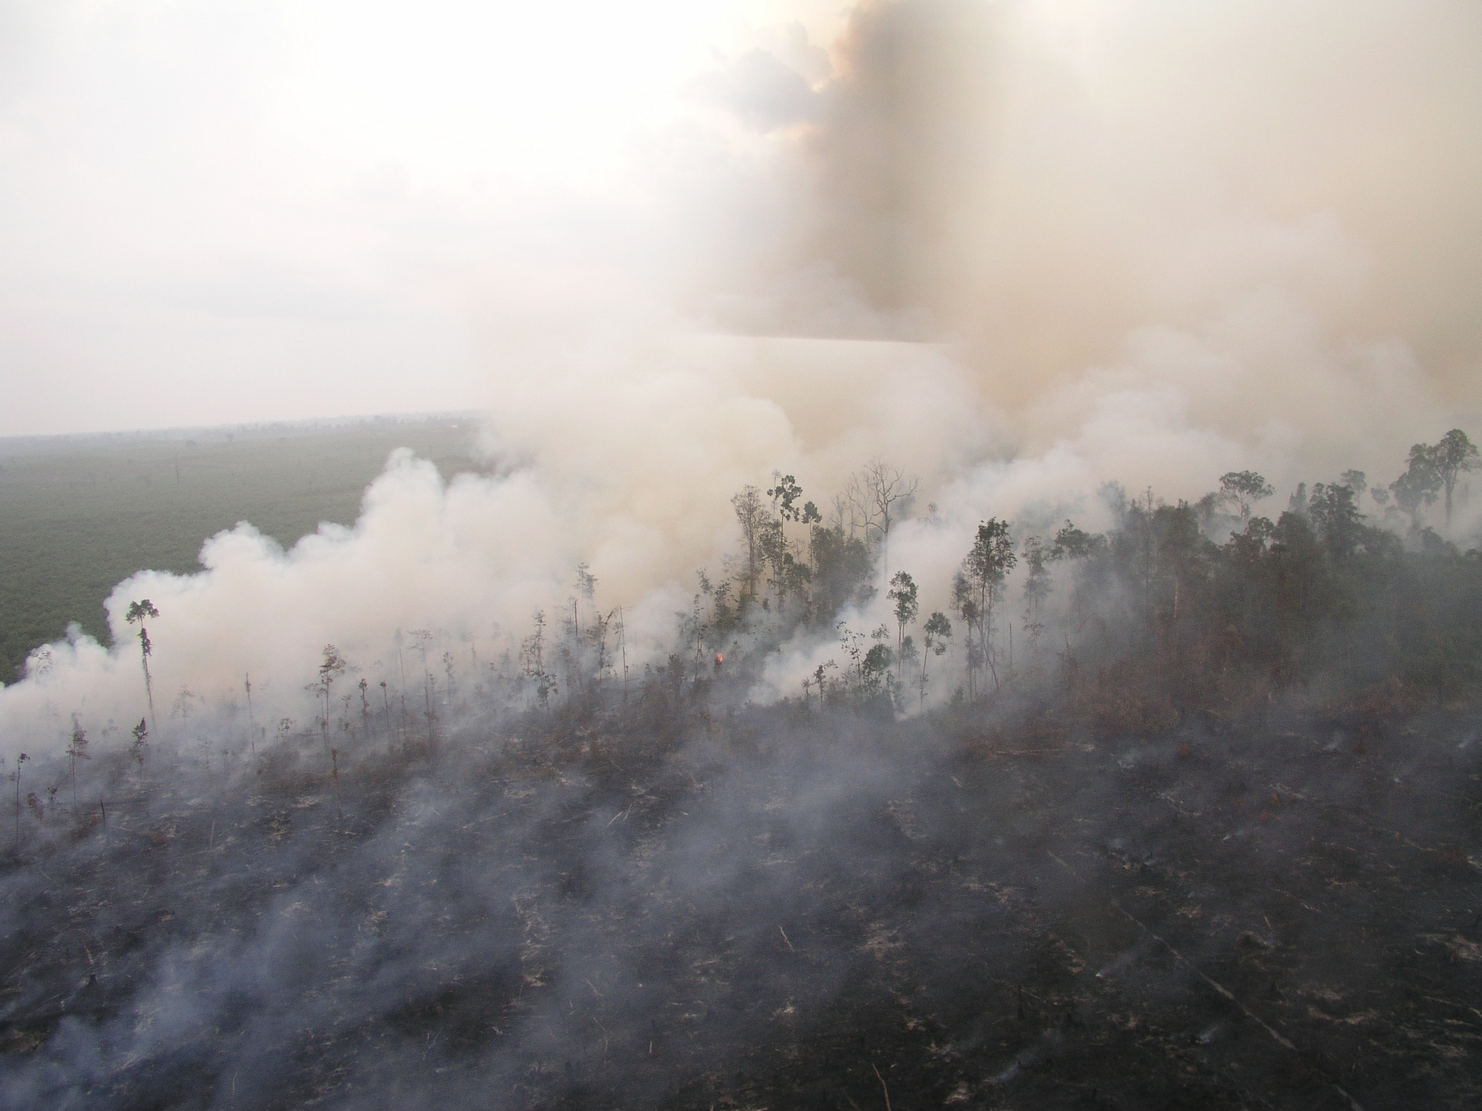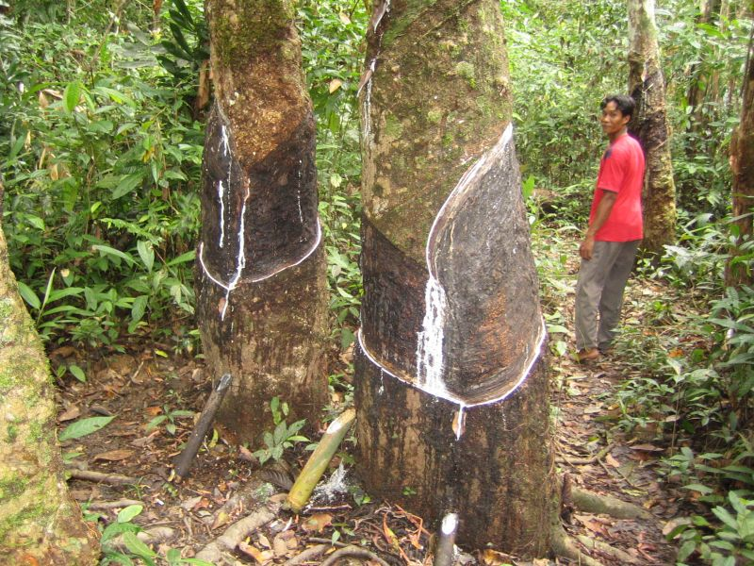
C
Emissions
Vulnerable
C Pools
Climate System
Climate Variability-El Nino
Climate Change
(+)
(+)
(+)
(-)
(-)
(-)
Mitigation
Adaptation
Regional Sustainable
Development
Impacts
Global
(climate change)
Regional
(haze: health, tourism, aviation)
Local
(industry: peat subsidence
local comm.: subsistence)
X
(+)
Human System
Land Use Change:
Deforestation, Drainage
Figure 3. Interactions and feedbacks of the carbon-climate-human system in tropical peatlands

Leadership, Partnership, and Participants
Leaders of this activity are Pep Canadell, Faizal Parish (Malaysia) and Daniel Murdiyarso (Indonesia). In order to bring the key communities in this work, the GCP has developed a partnership with the Global Environment Centre (Malaysia), and CIFOR (Indonesia).
About 60 people participated at the first workshop from the Asia Pacific region, Europe and USA.

Funding
Funding was secured for 2005-06 from Asia Pacific Network (Japan) and the Climate Change Forest and Peatland Project led by Wetlands International and Wildlife Habitat Canada and funded by CIDA.

Products
The three major products of this activity:
- An updated global database of extent and carbon stocks in tropical peatlands with an emphasis on Southeast Asia where the largest peatland areas are;
- A modelling capability to explore plausible future scenarios of carbon emissions under different land use and land management, and climate change.
- Special feature in ECOSYSTEMS:
- Global significance and vulnerability of carbon in tropical peatlands
Josep Canadell, Faizal Parish, Daniel Murdiyarso, Susan Page
- Extension and carbon content of tropical peatlands
Verhagen Jan, Bostang Radjagukguk, Nyoman Suryadiputra, Jian Li Asari, Bin Hassan, Seno Adi Gusti Zakaria Anshari et al.
- Land use/cover change in tropical peatlands: drivers, extension, C consequences, adaptation and mitigation
Daniel Murdiyarso, Kevin, Yumiko, Munoz, Arief, Zulfahmi, Nyoman, et al.
- The carbon balance of tropical peatlands (minus fire emissions)
Takashi Hirano, Jyrki Jauhiainen, Lulie Melling, Takashi Inoue, Takahashi, et al.
- Tropical Peatlands and Fire: drivers, extension and C emissions
Allan Spessa, Edvin Aldrian, Murphy, et al.
- Future Trajectories: scenarios of land use, climate, C emissions, impacts
Aljosja Hooijer, David Hilbert, Wenhong Li, John McGregor, Faizal Paris, Pep Canadell, et al.
- Ecological restoration of tropical peatlands
Susan Page et al.
Timetable
- First meeting took place in January 2006 in Pekanbaru, Sumatra (Indonesia). All participants
- Second meeting - carbon extension and stocks working group will take place in Jakarta, August 2006
- Third meeting - modelling working group will take place in Kuala Lumpur, August 2006.
- Fourth meeting - ecological processes working group (to be determined).
- Special feature in ECOSYSTEMS to be submitted in May 2007

- Vulnerabilities of drought and fire to the terrestrial carbon cycle

Background
Over the last century we have seen major modifications of the water cycle including the distribution, variability and trends of rainfall, runoff, and evaporation. Such changes are thought to result to some degree from increasing emissions of human-driven greenhouse gases (GHG), and consequently, expected to become even larger during the course of this century as GHG emissions increase.

Global Climate Models predict major changes of the water cycle over the next 100 years including the increase of i) global precipitation, ii) water stress in some regions, and iii) inter-annual variability and extreme events (eg, droughts, floods).

Changes in water cycle variables such as precipitation, runoff, streamflow, soil moisture, and atmospheric vapor pressure impact carbon stocks and fluxes (e.g., soil and ecosystem respiration, production) and disturbance events such as fire frequency and intensity. Fully coupled carbon-climate models suggest that biogeochemical and vegetation structure changes can be forced by drought and fire, thereby altering carbon exchange by terrestrial ecosystems. Robust simulations under projected climate change using such models remains a challenge.

In fact, recent climate trends and higher intra- and inter-annual variability may have increased the amplitude of the seasonal cycle of CO₂, however, it is not clear if or how these changes will lead to increased or decreased carbon storage. Initial results are suggesting a diminished strength of the terrestrial net carbon sin (Figure 4).


1997-98
SEA Tropical
1.4 PgC
01,02,03
SEA Trop.
1.2 PgC
1994-2002
High-Mid Latitude
Summers undo the benefits
of earlier spring
2003
Europe
0.5 PgC
2002-present
0.2 Pg C
2003
Siberia
0.2 PgC
1997
Amazon
Fire Year
2005
Amazon
1 Pg C
Figure 4. Bottom up calculations of carbon emissions from droughts (1994-2005)
Goals
To explore interactions between energy, water and carbon in the earth system caused by drought and variability of the water cycle and its effects on carbon exchange, ecosystem respiration, and on disturbance frequency and emissions.

Leadership and Participation
Leaders are Mike Raupach and Pep Canadell
40 people participated at the workshop from Australia, Europe, Japan, and USA.

Activity
Workshop in June 2006. One-event activity for the time being.

Funding
Australian Greenhouse Office and the European Space Agency

Products
A synthesis paper (in preparation).

4. Overall synthesis and Integration

Activity
To synthesize the results of various activities in an overarching global framework.

Leadership
Mike Raupach and Pep Canadell

Products
Raupach MR, Canadell JG (2006) Observing a vulnerable carbon cycle. In: Observing the Continental Scale Greenhouse Gas Balance of Europe (eds. H. Dolman, R. Valentini, A. Freibauer), Springer, Berlin (submitted).

Implementation – New Activity to begin in 2007

5. Vulnerabilities of the ocean C sink to warming and elevated CO₂
Prepared by Corinne Lequere

Background
The ocean CO₂ sink is one of the best known component of the global carbon budget, with an estimated value of around 2.2 and an error of around ±0.4 PgC/y for the 1990s. Simple steady-state models show that the ocean CO₂ sink will continue to increase as long as atmospheric CO₂ increases. However, this result assumes that the oceanic temperature, circulation, and biology, do not change.

Numerous oceanographic surveys have shown that (1) the ocean has in fact warmed significantly in the past 50 years to a depth of at least 700 m, (2) the surface salinity has changed roughly showing an enhancement of the water cycle, with fresher waters at high latitudes and more saline waters in the tropics, (3) ocean circulation has changed, with possibly a decreased Meridional circulation in the North Atlantic, an increase in El Nino frequency and intensity, and an increase in upwelling in the Southern Ocean. Large-scale changes in ocean circulation have also been highlighted by a worldwide decrease in sub-surface oxygen observed since the early 1980s.

Numerous studies have also identified changes in some aspect of marine biology, particulatly primary production and ecosystem composition. The warming of the ocean surface is expected to have influenced both primary production and respiration, with a net effect that is unknown. Furthermore, the surface ocean has become more acid due to rising CO₂ again with unknown consequences for marine ecosystem.

Except for warming and pH, we do not know if the observed changes in physical and biological variables are indicative of trends or if they reflect natural variability. We do know however that such large-scale change also influences the natural carbon cycle and the capacity of the ocean to take up anthropogenic CO₂.

The needs for the community are (1) to organize the observation network in order to detect changes in the CO₂ sinks, (2) to develop modeling experiments to assess the range of possible changes, and (3) to synthesize observations and model results. Much work for data co-ordination and some synthesis are already undertaken by the IOCCP. Some more work and co-ordination would be helpful on the modeling and synthesis side.

Activities
In trying to organize this activity, we ran into the problem that a workshop on surface ocean p CO₂ is already organized by the IOCCP for the spring of 2007. Thus it would be difficult to propose a similar activity within +/- 6 months of that workshop. We opted for merging the pCO₂ workshop with an additional day devoted to the vulnerability of ocean CO₂ sinks, led by the GCP.
This has the additional advantage of needing little extra travel from participants.

The aim of the April 2007 meeting is to identify what information already exists both on the data and modeling side, and to set up an agenda to enhance on-going efforts on the modeling and synthesis aspects of ocean vulnerability. We should aim to have a second, longer meeting approximately 1-1.5 years after April 2008.

Approximate time-line:
April 7 2007: one day meeting to identify existing information and set up activities
April 2007-mid-2008: co-ordination of modeling work to address gaps in our understanding
mid-2008: 3-day workshop to present new information and outline synthesis paper

Preliminary agenda for the April 2007 one-day meeting:
Global and long-term views from p CO₂ data (chair, Tilbrook ?)
- The GlobaView p CO₂ re-analysis (Taro Takahashi?)
- Decadal changes in the North Atlantic (Andy Watson and Ute Shluster?)
- Decadal changes in the North Pacific (Ishii ?)
- Decadal changes in the Equatorial Pacific (Feely ?)
- Decadal changes in the Southern Ocean (Lo Monaco, Metzl, Ishii ?)
- Coastal issues (Chen, Borges ?)

Global and long-term views from ocean models (chair Le Quere ?)
- How do ocean models benefit from p CO₂ data ? (Doney, Heinz ?)
- What do ocean models suggest for the future ? (L.Bopp)

Global and long-term changes : climatic trends, irreversibility ? (chair Metzl ?)
- SAM, NAO, ENSO (Le Quere)
- NAO and resources (Beaugrand ?)
- PDO and eco-systems (Chavez ?)
- PDO and CO₂ system (Rodgers ?)
plus discussions.

Questions to address during discussions:
- How do changes in ocean physics (temperature, salinity, circulation) impact the carbon cycle today, in the future, and in the far future?
- How can we link changes in oxygen and nutrients to changes in the carbon cycle?
- Can we quantify the impact of observed large-scale changes in marine biology on the carbon cycle?
- What are the projected impact of environmental changes on marine biology and the carbon cycle? (this includes the impact of T, pH, and light on different plankton types and on ecosystem composition)
- How large are the projected changes in the coastal carbon cycle?
- Should we expect a large response from changes in atmospheric dust deposition, river nutrient input, or dissolved organic matter?
- Are there instabilities and thresholds in the marine carbon cycle?
- How can we use evidence from the present and past to set bounds on the possible response of the carbon cycle to physical and biological changes in the future?

Participants and organization committee:
Chris Sabine, Maria Hood and Roger Dargaville from the IOCCP and Arthur Chen are all involved in the organization of this program. In addition to the people mentioned in the program, the following people could be invited: Niki Gruber, Steve Emerson or Curtis Deutsch, Richard Matear, Doug Wallace, Jim Orr, Marion Gehlen, Christoph Heinze, Ernst Maier-Reimer, Jorge Sarmiento, Ulf Riebesell, Christine Klaas, David Archer.

6. Vulnerability of Methane Hydrates (workshop proposal)
Prepared by Nebojsa Nakicenovic and Pep Canadell

Hydrates or clathrates are ice-like compounds in which various gases are held in crystalline cages formed by water molecules. Methane hydrates or clathrates contain methane, the main constituent of natural gas. They form under conditions of high pressure and low temperatures. During the 1940s problems with pipeline transmission of natural gas in cold regions led to widespread recognition that methane hydrates would be stable below ground in regions of permafrost. In these cold regions, drilling operations have to take special precautions to prevent explosive release of methane as the drill penetrates zones of methane hydrates. Methane clathrates or hydrates are widespread in areas of permafrost on and off-shore such as in the polar regions and in sediments on the continental shelf below the ocean floor at shallow depths where conditions are appropriate for their formation (MacDonald, 1990 and 1998; Kvenvolden, 1998).
Methane hydrates are an energy source of potentially staggering magnitude compared with other known hydrocarbon deposits. It is thus not surprising that a number of scientific inquiries around the world are evaluating gas hydrates as a potential energy source (eg. Nakicenovic et al., 2000, IGU, 1997). It is plausible that technologies for recovering these resources economically could be developed in the future, in which case gas resource availability would increase enormously (MacDonald, 1990a; MacDonald, 1990b).
At the same time, methane hydrates are a factor in climate change. Methane is a potent greenhouse gas which can be released from hydrates by pressure reduction due to giant submarine landslides or by warming of the subsurface sediments (MacDonald, 1998). Methane hydrates have outgassed in the deep past in periods of warmer climates and there is an increasing concern today that global warming would result in substantial methane releases into the atmosphere causing catastrophic climate change.
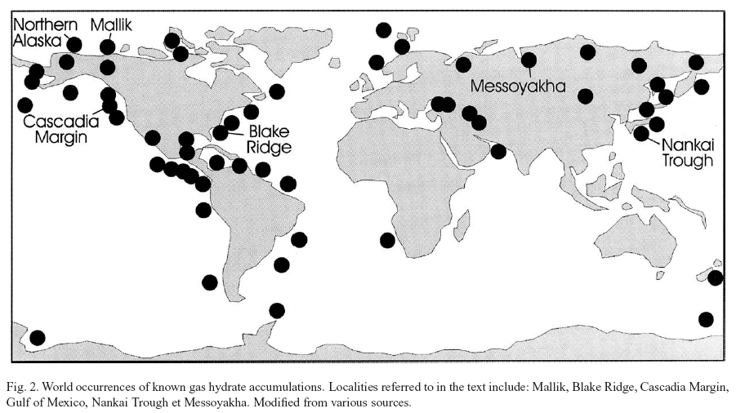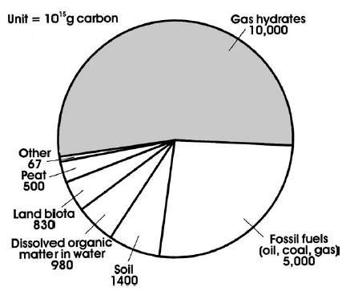
Occurrence: Beneath oceans and in polar regions
Carbon content
Figure 5. Distribution and carbon content of clathrates. Source: Beauchamp 2004
The exact quantities of methane that might be in the form of clathrates are subject to speculation (Figure 5). However, the existence of gas hydrates has been confirmed by direct evidence through sampling and by indirect evidence through geochemical and geophysical investigations. In 1972, the first successful recovery of natural methane hydrate occurred during pressurised coring operations in Prudhoe Bay at depths between 577 and 766m (MacDonald, 1998). Despite the difficulties associated with the recovery of material that rapidly decomposes at low pressures, numerous samples of methane hydrates have been recovered in the course of the scientific program of deep drilling in the ocean. To date, samples have been recovered in 14 areas of the world, while indirect evidence has been found in 30 other areas. Many occurrences of methane hydrates on the continental shelves of all oceans have been inferred based on special geophysical exploration techniques such as bottom-stimulating reflection. At this juncture, resource estimates for gas hydrates are highly uncertain. BGR (1998) reports global clathrate occurrences of more than 9,000 Tm³ (333 ZJ). Other estimates report clathrates as high as 20,000 Tm³ (740 ZJ) (MacDonald, 1990a; MacDonald, 1990b; Kvenvolden, 1988; Collet, 1993). Thus, the methane hydrate resource base measured in energy content might be up to five times larger than that of coal. In terms of carbon, it could contain up to ten thousand times more carbon than the atmosphere equaling in orders of magnitude to carbon dioxide dissolved in the oceans.
Methane can be recovered from natural gas hydrates by depressurization or thermal disassociation. How much can be practically recovered at affordable costs is however highly uncertain. Many offshore hydrate occurrences appear to contain free methane as a gas beneath solid hydrate layers. This is because the stability of hydrates depends both on pressure and temperature. Even at high pressures, the reservoir temperature can be too high so that free gas may accumulate and be trapped beneath solid hydrate. An emerging view is that this free gas is easier to recover directly than the gas from solid hydrates (Max et al., 1997). For example, free gas recovery would depressurize the reservoir, which would lead to hydrate melting and thus to free gas replenishment. The process could continue as long as the hydrate layer remains thick enough to cap the free gas below.
The direct recovery of methane from solid hydrate would in any case have a positive energy balance. The energy required to liberate the methane is likely to be 13 to 17 times smaller than the thermal energy contained in the released methane (MacDonald, 1998). However, the economics of methane production from hydrates are very uncertain due to the lack of operational experience. Also uncertain are the prospects for developing technologies for commercial exploitation of methane clathrates as a source of energy. Nevertheless, such technologies might bear fruit at some stage and radically alter current perceptions regarding natural gas availability (IGU, 1997).
The only known production of natural gas from hydrates occurred in the Soviet Union with the partial development of the Messoyakha gas field, estimated to contain billions of cubic meters of methane hydrates. The production method involved injecting methanol to decompose the hydrates. Unfortunately, this project has been an economic failure because of the high cost of methanol (MacDonald, 1998).
Currently, attractive technological proposals are still outstanding on how methane hydrates could be recovered economically. However, given its enormous resource potential, it is plausible to expect that extraction methods will eventually be developed if long-term global gas demand warrants clathrate recovery. At present, there is little private-sector interest in better understanding the magnitude and cost dimensions of the methane hydrate resource, because conventional natural gas supplies are abundant on the time scales of interest to business (Williams et al., 2000). But having such an understanding is important in decisions about relative RD&D priorities that relate to unconventional gas resource development and associated technologies in the near term. For this reason, as well as to better understand the theoretical potential of the hydrate resource and the attractions of natural gas as an energy carrier in general, there are several research projects underway in Japan, Russia, Norway, India and the US to examine the viability of future gas hydrate recovery (Collet et al., 1998 and BGR, 1998). Most recently, the panels convened by the US President’s Committee of Advisors on Science and Technology in the United States urged international collaborative RD&D in this area building on embryonic efforts already launched in Japan, Russia, and India (PCAST, 1997 and PCAST, 1999)
Given the importance of methane hydrates as both a potential source of natural gas and as a catastrophic danger if substantial quantities outgas with climate warming, we propose to organize a perspective meeting to discuss both of these dimensions of methane hydrates. The emphasis would be on the review of the current knowledge and on major controversies surrounding the hydrates both as a potential energy source and as a potential source of catastrophic climate change. The meeting would last two and half days and focus on the first day on the climatic dimensions of methane hydrates, ranging from outgassing during paleoclimates to future dangers of substantial releases of methane to the atmosphere due to climate warming. The second day would focus on energy-related dimensions, ranging from possible technologies for natural gas production from hydrates and storage of captured carbon from the produced methane to assessment of the potential methane resource base. The last morning would be devoted to the review of major controversies surrounding hydrates and to a panel discussion of the ways forward including possible agenda of future research priorities and experiments.

Products
The group will explore writing a short paper for Science/Nature showing the potential vulnerabilities of clathrates to global warming (climate forcing) and due to the possibility of clathrates becoming part of the energy mixture sometime this century (human forcing).
A short document will identify the key research and synthesis priorities for the global community and for the GCP.

Proposed Venue and time
IIASA, Austria, March 2007

Implementation – Exploratory subjects for possible future Activity

  - Absence of forest policy: Illegal logging in the Russian boreal forest
The fall of the Soviet Union in 1991 brought a rapid decentralisation and subsequent diminished capacity to enforce forest management practices resulting in:
  - a large increase in logging taking place due to high demand for wood by China; and
  - a loss of the capacity of fighting forest fires (due to loss of funding)
What are the C emissions from increased logging and fire frequency/area burned? What new livelihood opportunities have been brought by the new socio-political conditions? What are the feedbacks between increased logging and an emerging legal market for carbon trading?

- Selective logging in tropical regions.
Selective logging increases fire risk conditions in tropical regions with the result of larger wildfires during ENSO-events in regions where fire is used as a clearing tool. What are the C emissions of these fires in a warmer and more fragmented tropical forest? What are the human responses to the increase of fires, mediated by livelihood risk and smoke-health problems? How can we make less vulnerable the carbon pools through different management strategies?

- Burning of agriculture residues.
There are choices on what to do with agriculture residues, including burning or energy production (gasifiers, anaerobic combustion). The signatures of these two management options are likely to be quite different in the global carbon cycle.

- Vulnerability of pristine forest.
Pristine forests have a large biomass, and therefore the impact of their loss to climate is potentially highest. Any replacement of mature forest by secondary forest will result with a loss of C to the atmosphere. Similar to the fire loop. The near-causes of this vulnerability will be driven by national land use policies often driven by both national and international forces (e.g, market demands).

